Маханов 1исп11-17 22-23/03/2021

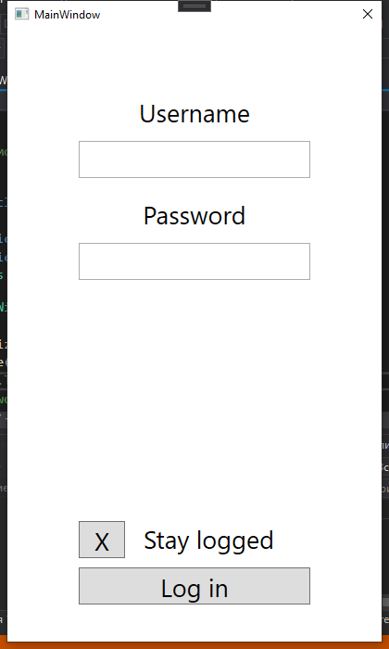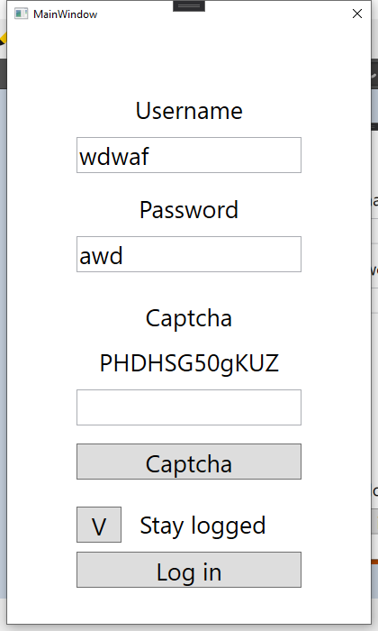

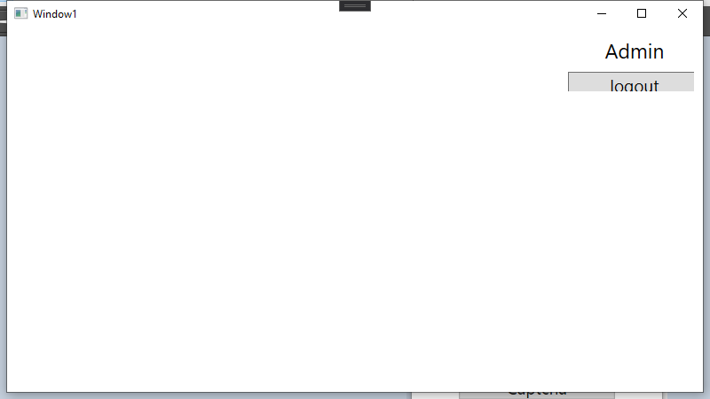

<https://github.com/SeyVetch/WpfApp11> (MASTER)